**Experiment No: 14**

**Experiment Name:**FCFS Disk Scheduling algorithm implementation.

**Aims and Objectives:** To learn about FCFS Disk Scheduling Algorithm. Implement FCFS Disk Scheduling algorithm by using c program. And testing the program different input and find output.

First Come First Serve (FCFS)

1. Requests are serviced in the order in which they arrive.
2. The algorithm is easy to implement.
3. Bad algorithm as it may involve lots of unnecessary seek distance

**Source Code:**

#include<stdio.h>

#include<stdlib.h>

int main()

{

int queue[20],n,head,i,j,k,seek=0,max,diff;

float aver;

printf("enter the max range of disk");

scanf("%d",&max);

printf("enter the size of queue request");

scanf("%d",&n);

printf("enter the queue");

for(i=1; i<=n; i++)

{

scanf("%d",&queue[i]);

}

printf("enter the initial head position");

scanf("%d",&head);

queue[0]=head;

for(j=0; j<=n-1; j++)

{

diff=abs(queue[j+1]-queue[j]);

seek+=diff;

printf("move is from %d to %d with seek %d\n",queue[j],queue[j+1],diff);

}

printf("total seek time is%d\n",seek);

aver=seek/(float)n;

printf("avrage seek time is %f\n",aver);

return 0;

}

**Output:**

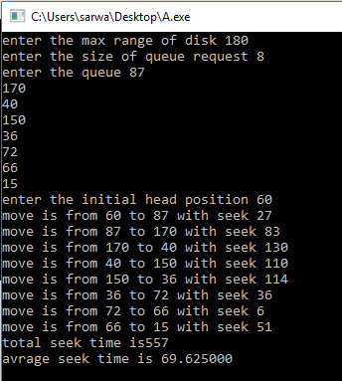

**Conclusion:**

We have learnt about FCFS Disk Scheduling algorithm. We have also learnt how to implement FCFS Disk Scheduling algorithm by using C program and testing the program different input and find output.